Week 7 Practical

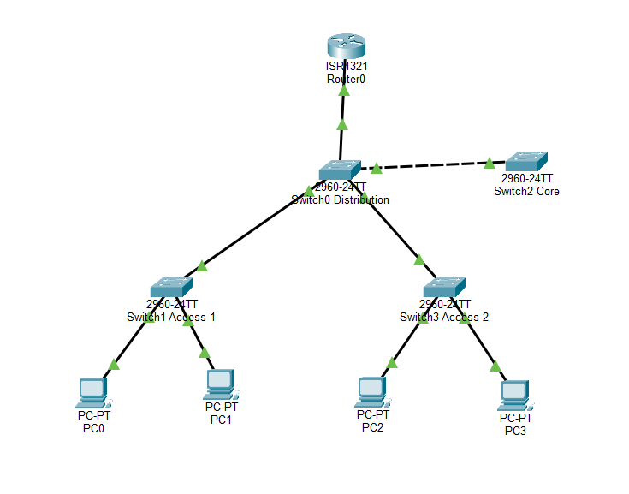
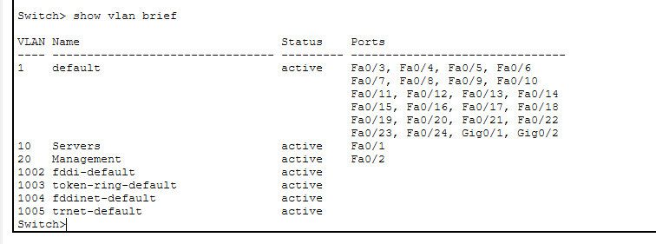
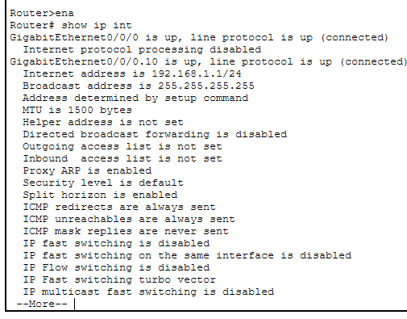

Step 2:
Each switch maintains its own VLAN database. A trunk port can only carry VLANs that are defined locally. If a VLAN is missing, the switch won’t recognize the tag and will discard the frame.

2. Access port: Connects end devices (PCs, printers, IP phones)
Trunk port: Connects switches together or to routers.
Uplinks should use trunk ports

3. show vlan brief

Step 3:
On Cisco devices, the encapsulation protocol you should use for trunk ports is IEEE 802.1Q (dot1q). Its Industry Standard
No, it prevents unauthorized VLANs from being extended into parts of the network where they shouldn’t exist.

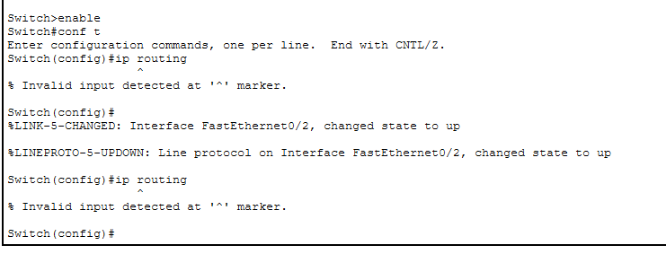
I tried the Inter-VLAN Routing Mr still giving me problems

